**Face feature detection**

**Executive summery**

In this project, I implement a face detection program using C++ and OpenCV for still images.

In each picture the algorithm will detect all faces, and in each face, it will mark the nose, eyes and lips on top of the original picture.

The main engine behind this algorithm is based on Haar cascade classifications, where each feature (face, nose etc.) is detected by a different classification pretrained model that I found online.

**Alternatives overview (amongst many)**

1. Haar feature-based cascade classifiers *-* an effective object detection method proposed by Paul Viola and Michael Jones in their paper, "Rapid Object Detection using a Boosted Cascade of Simple Features" in 2001. An ML based approach where a cascade function is trained from positive and negative images (i.e. with and without the sought feature).

* ***Advantages*** *- Fast, easy to apply and OpenCV integrated*
* ***Disadvantages*** *- less accurate compared to other approaches, can be a pain to tune parameters.*

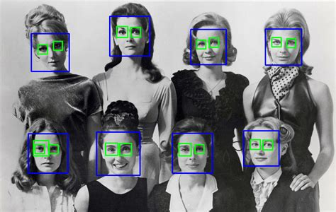

1. *HOG + Linear SVM: Typically, more accurate than Haar cascades with less false positives. Normally takes less parameters to tune at test time. Can be slow compared to Haar cascades.*
2. **Deep learning-based detectors -** 
   1. Dlib - A collection of miscellaneous algorithms in Machine Learning, Computer Vision, Image Processing, and Linear Algebra.

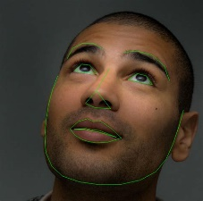

* 1. OpenFace - an open source facial behavior analysis toolkit intended for facial landmark detection, head pose estimation, facial action unit recognition, and eye-gaze estimation.

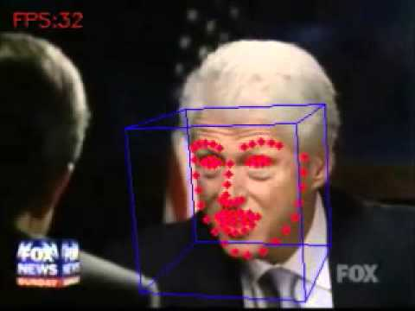

1. YOLO - real time feature detection base on a CNN, good for applying a single neural network to a full image. This network divides the image into regions and predicts bounding boxes and probabilities for each region. These bounding boxes are weighted by the predicted probabilities.

The model has several advantages over classifier-based systems. It looks at the whole image at test time, so its predictions are informed by global context in the image. It also makes predictions with a single network evaluation which makes it extremely fast and suitable for video streams.

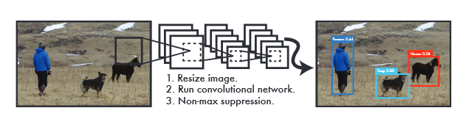

I choose to work with the Haar method, mainly because as opposed to other methods it allows working with the building blocks (the classifier for each feature, i.e. nose, mouth etc.) separately and not being completely ML-based, it allows a better understanding and flexibility of the algorithm. Using complete DL methods such as the OpenFace, while achieving better results, are in a sense “black box” algorithms and are hence a bit less intuitive to follow along and alter if needed.

**Prerequisites *(the code is written with the following preinstall environments)***

OpenCV 3.4.4

Visual studio 2017

**Graphical presentation of the algorithm:**

*Block diagram explaining the algorithm*

**Main blocks of the algorithm:**

Define the classifier argument and model path. load the model

CascadeClassifier nose_cascade;

String nose_cascade_name = "C:\\OpenCV3\\opencv\\sources\\data\\haarcascades\\haarcascade_mcs_nose.xml";

if (!nose_cascade.load(nose_cascade_name))

{

std::cout << "Error loading nose cascade\n";

return -1;

};

Mat frame = imread("Matan.jpg", IMREAD_COLOR);

Load the picture

Mat frame_gray;

cvtColor(frame, frame_gray, COLOR_BGR2GRAY);

equalizeHist(frame_gray, frame_gray);

Convert the picture to gray scale

Detect all faces in frame in return will get Vector of rectangles where each rectangle contains the detected object

std::vector<Rect> faces;

face_cascade.detectMultiScale(frame_gray, faces);

Mark with circle all the faces in the picture

for (size_t i = 0; i < faces.size(); i++)

{

Point center(faces[i].x + faces[i].width / 2, faces[i].y + faces[i].height / 2);

ellipse(frame, center, Size(faces[i].width / 2, faces[i].height / 2), 0, 0, 360, Scalar(0, 0, 255), 4);

In the same “face-wise loop” detect specific features using Haar classifier nicer

std::vector<Rect> nose;

nose_cascade.detectMultiScale(faceROI, nose, 1.3, 5, 0 | CV_HAAR_FIND_BIGGEST_OBJECT);

for (size_t j = 0; j < eyes.size(); j++)

{

Point nose_center(faces[i].x + nose[j].x + nose[j].width / 2, faces[i].y + nose[j].y + nose[j].height / 2);

int radius = cvRound((nose[j].width + nose[j].height)*0.025);

circle(frame, nose_center, radius, Scalar(255, 0, 0), 4);

}

}

Plot and save the picture with the added features

imshow("Face feature detected", frame);

waitKey(0);

imwrite("Face_detection.jpg", frame);

**Cascade Classifier - *detectMultiScale* Parameters (for tuning purposes)**

|  |  |
| --- | --- |
| image | Matrix of the type CV_8U containing an image where objects are detected. |
| objects | Vector of rectangles where each rectangle contains the detected object, the rectangles may be partially outside the original image. |
| numDetections | Vector of detection numbers for the corresponding objects. An object's number of detections is the number of neighboring positively classified rectangles that were joined together to form the object. |
| scaleFactor | Parameter specifying how much the image size is reduced at each image scale. |
| minNeighbors | Parameter specifying how many neighbors each candidate rectangle should have to retain it. |
| minSize | Minimum possible object size. Objects smaller than that are ignored. |
| maxSize | Maximum possible object size. Objects larger than that are ignored. If maxSize == minSize model is evaluated on single scale. |

**Results**

In the pictures below, we can see a couple of late-night photo of me (and a random person that I found online) with the features marked on it

Blue dots mark the eyes, gray for the nose and greenish for the mouth.

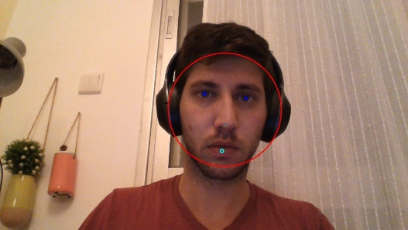 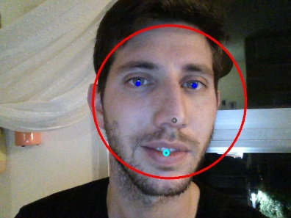

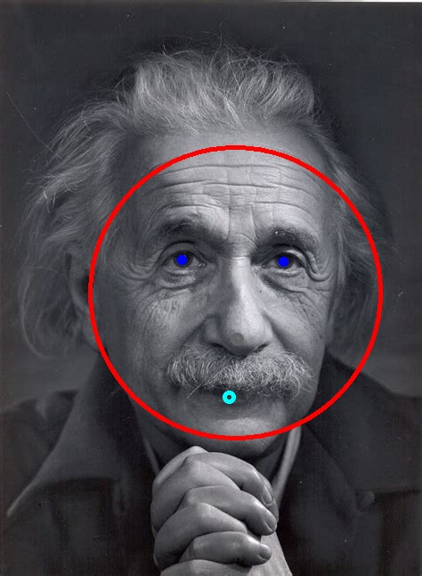

**Conclusion**

To get better classification results we can use more training pictures for each classifier as well as integrate some prior knowledge about the given picture (e.g. person pose, scale etc.) so we can improve the feature estimation accuracy.

preprocessing of the data and the input (e.g. filtering) might improve the classification results (for example sharpening or contrasting the image)

In aim to speed up the classification we could use the GPU for multithread computation (run classification in parallel) or use several external cores.

DL, as we discuss in the alternatives review, could also potentially derive a better classification result for more advanced applications (feature-wise) – but will also need more data to train on.

**References**

* Haar Cascade Classifier code:
  + <https://docs.opencv.org/3.4.4/d5/d54/group__objdetect.html>
  + <http://alereimondo.no-ip.org/OpenCV/34>
  + <https://github.com/opencv/opencv/tree/master/data/haarcascades>
  + <http://www.willberger.org/cascade-haar-explained/>
  + <https://docs.opencv.org/3.4.4/d7/d8b/tutorial_py_face_detection.html> (OpenCV Python tutorial)
  + <http://comp3204.ecs.soton.ac.uk/cw/viola04ijcv.pdf>
  + <https://www.youtube.com/watch?time_continue=216&v=hPCTwxF0qf4>
* **OpenFace** 
  + <https://github.com/TadasBaltrusaitis/OpenFace>
  + <http://elijah.cs.cmu.edu/DOCS/CMU-CS-16-118.pdf>
* **Dlib** -
  + <http://dlib.net/>
  + <https://en.wikipedia.org/wiki/Dlib>
  + <https://github.com/davisking/dlib>
* **YOLO** 
  + <https://github.com/opencv/opencv/blob/3.4/samples/dnn/object_detection.cpp>
  + <https://pjreddie.com/darknet/yolo/>
  + <https://towardsdatascience.com/yolo-you-only-look-once-real-time-object-detection-explained-492dc9230006>
  + <https://arxiv.org/pdf/1506.02640.pdf>

**Appendix A -** Haar feature classifier explained in detail

Haar Cascade is a machine learning object detection algorithm used to identify objects in an image or video and based on the concept of ​​ features proposed by Paul Viola and Michael Jones in their paper "Rapid Object Detection using a Boosted Cascade of Simple Features" in 2001.

Initially, the algorithm needs a lot of positive images (i.e. images of faces) and negative images (i.e. images without faces) to train the classifier. From these pictures we can extract the features later sought by the classifier.

First step is to collect the Haar Features. A Haar​ feature considers adjacent rectangular regions at a specific location in a detection window, summing up the pixel intensities in each region and calculating the difference between these sums.

But among all these features we calculated, most of them are irrelevant. To choose the most relevant ones we are using a concept called Adaboost which selects the best features and trains the classifiers that use them. This algorithm constructs a “strong” classifier as a linear combination of weighted, simple “weak” classifiers.

During the detection phase, a window of the target size is moved over the input image, and for each subsection of the image the Haar features are calculated. This difference is then compared to a learned threshold that separates non-objects from objects. Because each Haar feature is only a "weak classifier”, many Haar features are necessary to describe an object with sufficient accuracy and are therefore organized into cascade classifiers to form a strong classifier.

